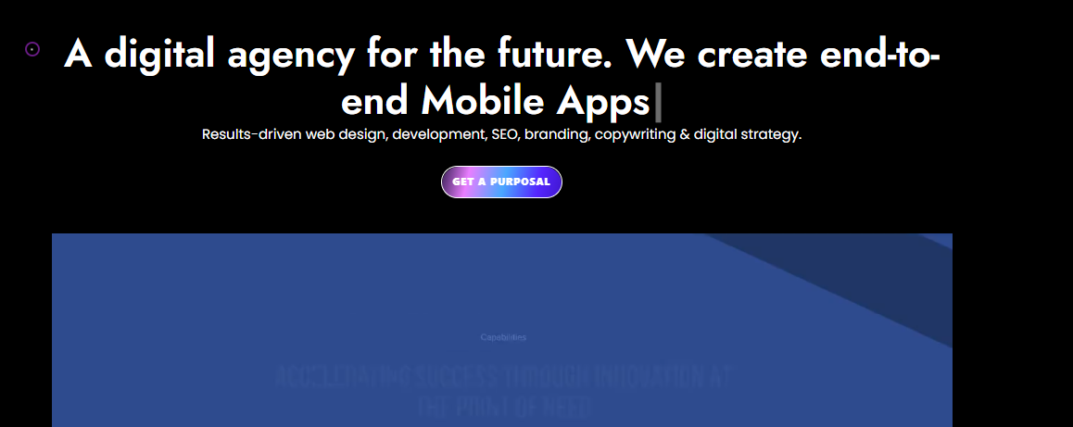 **A cutting-edge digital agency specializing in custom website design and development**

Customized Solutions for website design and development, emphasizing results.

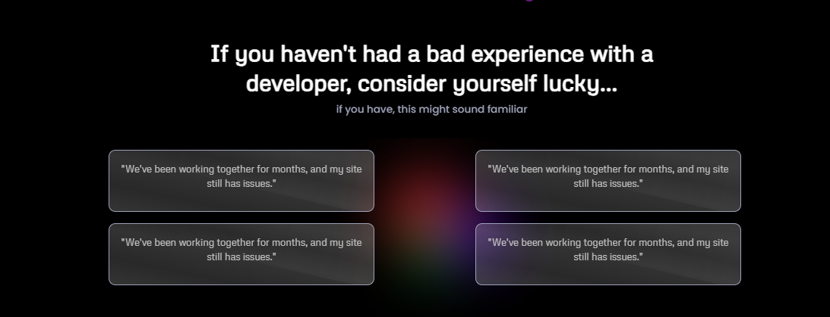

**Grow Your Brand with Our Unique Approach to Developing Custom Websites**

Your Vision, Our Knowledge of Developing Custom Websites

* We create custom websites tailored to your business's unique needs, ensuring a distinctive online presence that stands out.
* Implement strategic digital transformation to propel your business forward by integrating advanced technologies.
* Our SEO-centric approach ensures online success by maximizing visibility and organic traffic to your website.
* Experience a collaborative partnership with transparent communication, ensuring your vision is surpassed through iterative enhancement.

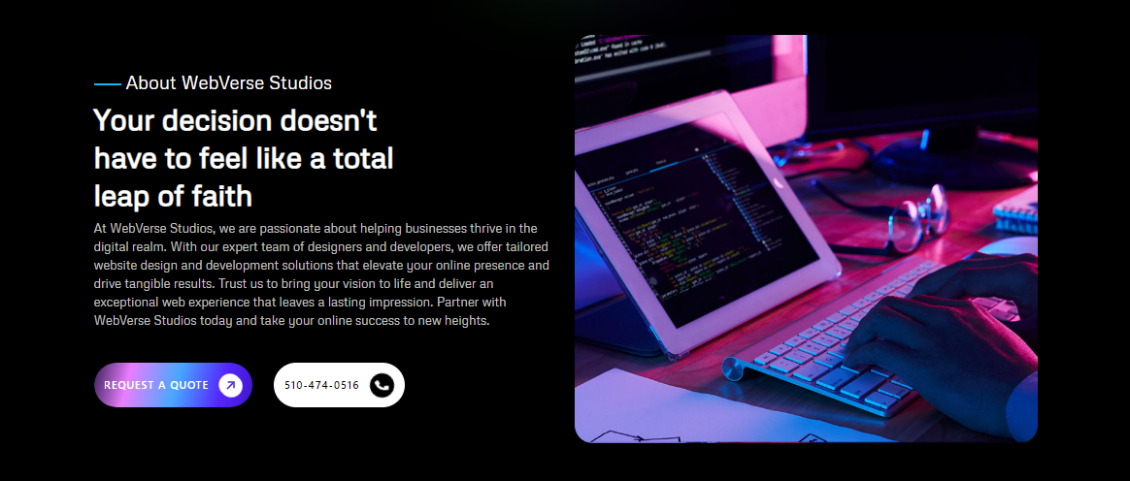

**About WebVerse Studios**

Your Partner for Transparent, Visionary Web Solutions

At Webverse, we use custom website development and design to redefine digital excellence. We create distinctive online identities with a passion for innovation, each one customized to meet the particular needs of our clients. Your website will be both visually appealing and resilient thanks to the strategic approach we take and the integration of cutting-edge technologies. We optimize visibility and organic traffic for online success, focusing on SEO and a transparent, cooperative process to enhance your idea into a digital masterpiece.

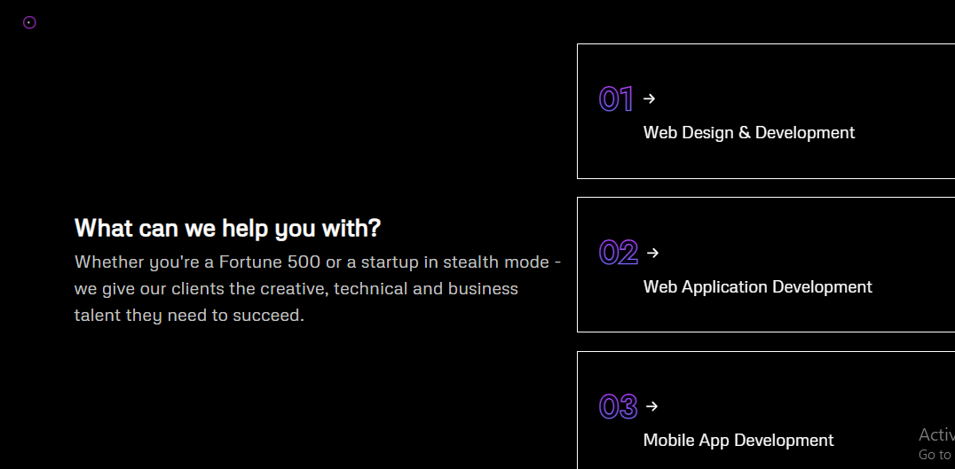

**What can we do to help you?**

We provide our clients with the business, technical, and creative talent they need to succeed, whether they are Fortune 500 businesses or startups in stealth mode.

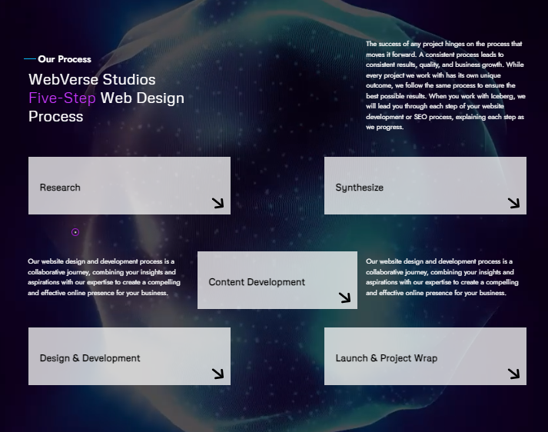

Our Process  
WebVerse Studios Five-Step Custom Website Process

Any project's progress depends on the process used to carry it out. Consistent outcomes, quality, and business expansion follow from a consistent process. Although each project we work on has a distinct conclusion, we constantly stick to the same process to ensure the best possible results. When you work with Iceberg, we will walk you through the entire process of developing a Custom Website or optimizing your website, providing you with clarification at every step.

1. **Discovery and Consultation:** We begin by understanding your vision and goals. Through in-depth consultations, we gather insights to shape a strategy that aligns with your brand identity and objectives.
2. **Strategic Planning:** Our team develops a comprehensive plan, outlining the design, functionality, and technology needed to bring your vision to life. This stage lays the foundation for a website that not only meets but exceeds expectations.
3. **Creative Design and Development:** With a strategic roadmap in place, our designers and developers collaborate to create a visually stunning and high-performing website. We prioritize user experience, ensuring seamless navigation and engagement.
4. **Testing and Quality Assurance:** Rigorous testing is conducted to ensure every aspect of your website functions flawlessly. From performance testing to cross-browser compatibility checks, we leave no stone unturned to deliver a polished and reliable product.
5. **Launch and Ongoing Support:** Your website is launched with precision. We provide ongoing support to address any post-launch needs and ensure your digital presence continues to evolve with the ever-changing online landscape.

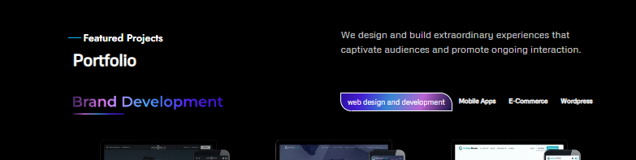

Featured Projects

Portfolio

We develop and build wonderful experiences that captivate audiences and promote continuous engagement.



**OUR COMPETITIVE PACKAGES**

With our custom website design packages, you can accomplish customized excellence which aims to exceed your digital goals and improve your online presence.

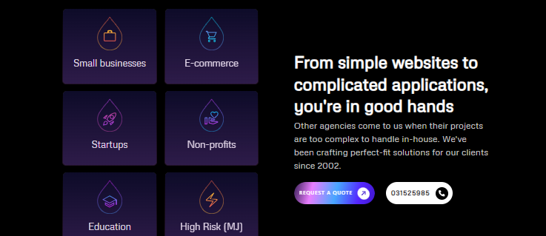

**For simple Custom website design and Development, you're in good hands**

You can rely on us for streamlined custom website development. Because of our expertise, the process is simple and efficient, and you'll receive a website that is perfect for your needs.

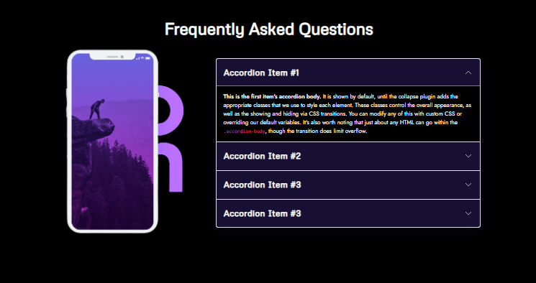

**Frequently Asked Questions**

**How long does it take to develop a custom website?**

Timelines vary based on complexity, features, and client feedback. Typically, our process takes a few weeks to a few months.

**What input do I have in the design process?**

Your input is crucial. We involve you in consultations, design reviews, and feedback sessions to ensure the website aligns with your vision.

**Can you optimize my website for search engines?**

Absolutely. We integrate SEO best practices during development to enhance your site's visibility and improve its ranking on search engines.

**Do you provide ongoing support after the website is live?**

Yes, we offer post-launch support. Whether it's troubleshooting, updates, or additional features, we're here to ensure your website remains optimal and up-to-date.

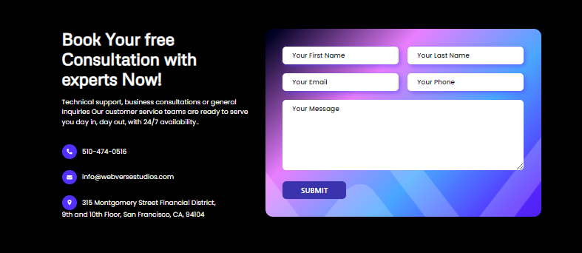

**Book Your Free Expert Consultation Now!**

Book your place now for a free consultation with an expert! Together, we will explore your requirements and develop a customized solution.